Data Flow Diagram (DFD) - Level 0 (Context Diagram)
This diagram shows the Immunization Tracker system as a whole and its data flows to and from external entities.
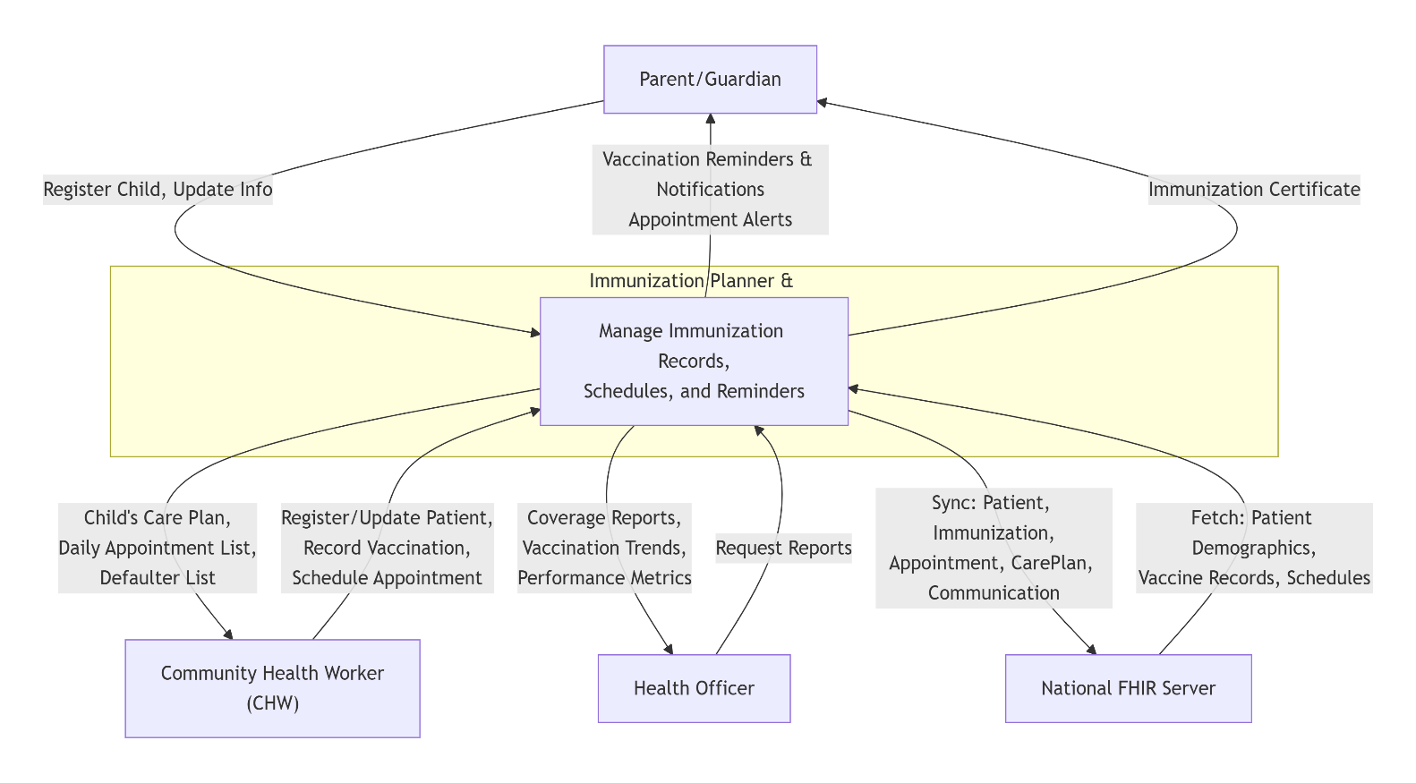

Data Flow Diagram (DFD) - Level 1
This diagram decomposes the main system into its key sub-processes, data stores, and detailed data flows.
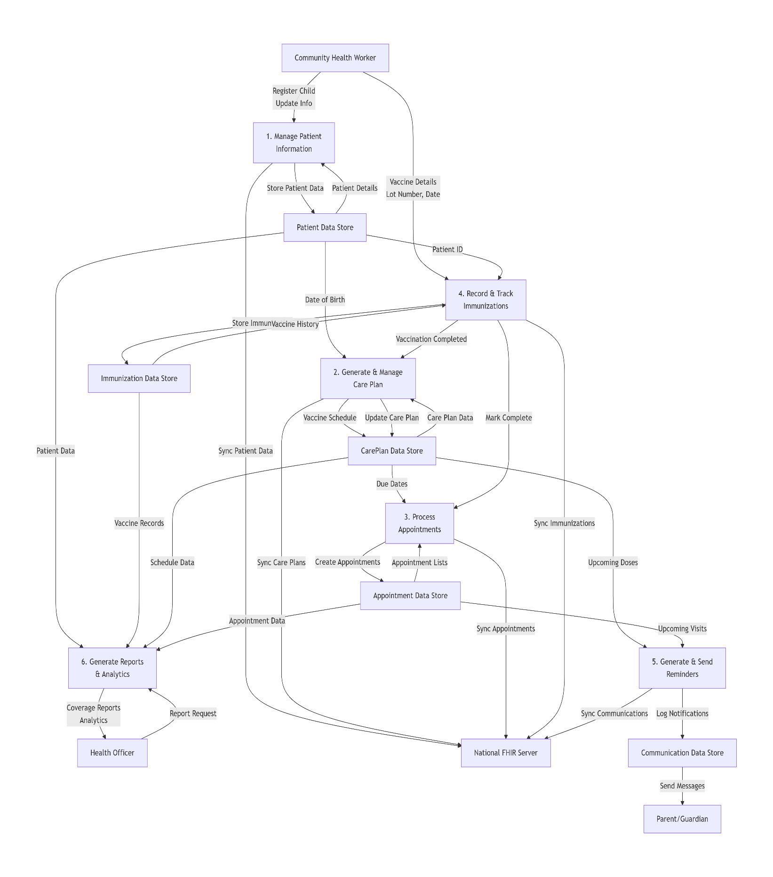
Level 1 Processes:
- Manage Patient Information: Handles all registration and updates of child/guardian details. Checks for duplicates and stores data in the Patient store, syncing with the FHIR server.
- Generate & Manage Care Plan: Automatically creates a personalized vaccination schedule (CarePlan) based on the child's date of birth from the Patient store. Updates the plan when a vaccination is recorded.
- Process Appointments: Automatically creates appointments in the Appointment store based on the due dates in the CarePlan. Manages rescheduling and provides daily lists for CHWs.
- Record & Track Immunization: The core process for logging vaccinations. It takes input from the CHW, validates it, and stores it in the Immunization store. It then updates the corresponding Appointment status and triggers the CarePlan to update its progress.
- Generate & Send Reminders: This process continuously checks the CarePlan and Appointment stores for upcoming due dates. It generates reminder messages, logs them in the Communication store, and sends them via SMS/Push Notification to Parents. It also syncs these communication logs with the FHIR server.
- Generate Reports & Analytics: This process serves Health Officers by querying all data stores (Patient, Immunization, Appointment) to generate coverage reports, defaulter lists, and other analytics.

